CREATE THE REGISTRATION INTERFACE

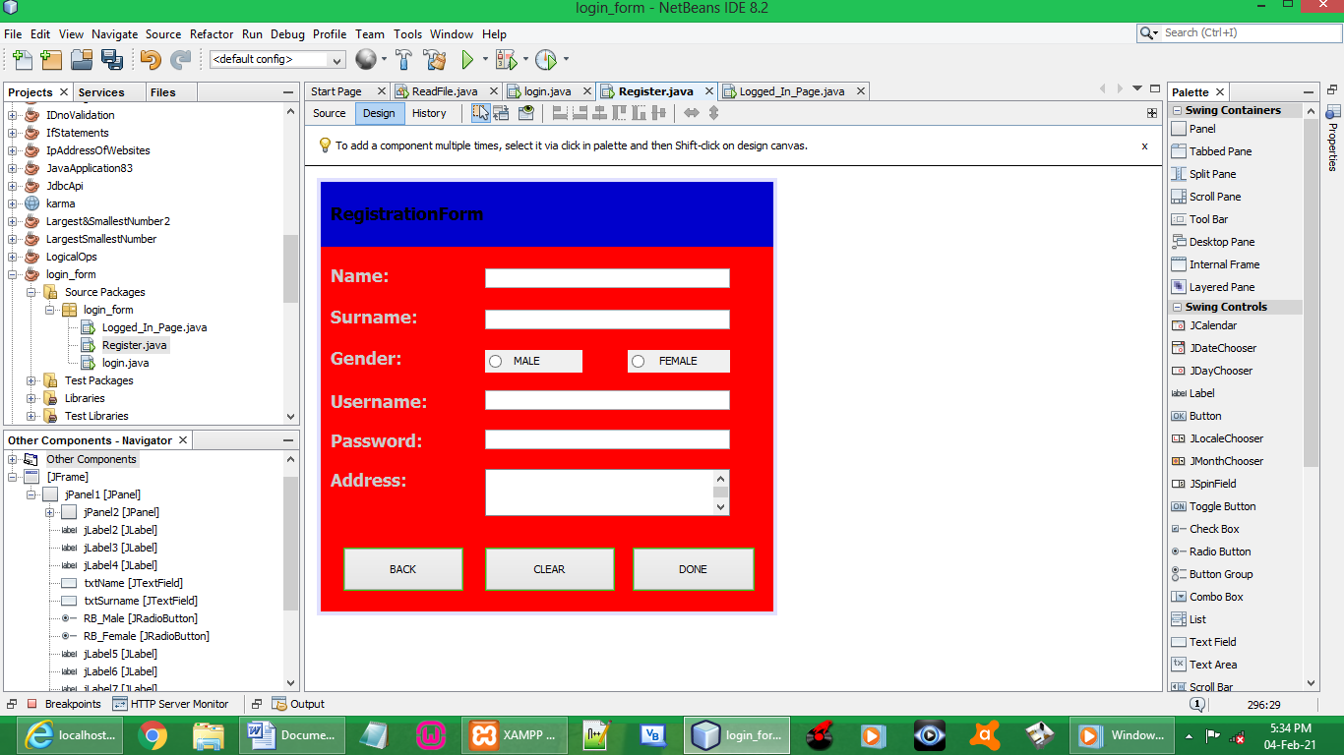

CODES:

import java.sql.Connection;
import java.sql.DriverManager;
import java.sql.PreparedStatement;
import java.sql.ResultSet;
import java.sql.SQLException;
import java.util.logging.Level;
import java.util.logging.Logger;
import javax.swing.JOptionPane;

BUTTON BACK:

txtName.setText("");
txtSurname.setText("");
RB_Male.setText("");
RB_Female.setText("");
txtUsername.setText("");
txtPassword.setText("");
TA_Address.setText("");

login log = new login();
log.setVisible(true);

BUTTON CLEAR:

txtName.setText("");
txtSurname.setText("");
RB_Male.setSelected(false);
RB_Female.setSelected(false);
txtUsername.setText("");
txtPassword.setText("");
TA_Address.setText("");

FUNCTION:

private String gender;

BUTTON DONE (register):

String name = txtName.getText();
String surname = txtSurname.getText();
String username = txtUsername.getText();
String password = String.valueOf(txtPassword.getPassword());
String address = TA_Address.getText();

if (name.isEmpty()){
JOptionPane.showMessageDialog(null, "Enter Your NAME");
}
else if (surname.isEmpty()){
JOptionPane.showMessageDialog(null, "Enter Your SURNAME");
}
else if (!RB_Male.isSelected() && !RB_Female.isSelected()){
JOptionPane.showMessageDialog(null, "Select Your GENDER");
}
else if (username.isEmpty()){
JOptionPane.showMessageDialog(null, "Enter Your USERNAME");
}
else if (password.isEmpty()){
JOptionPane.showMessageDialog(null, "Enter Your PASSWORD");
}
else if (address.isEmpty()){
JOptionPane.showMessageDialog(null, "Enter Your ADDRESS");
}
else if (checkUsername(username)){
JOptionPane.showMessageDialog(null, "Username Already Exist, Type In A New Username");
}
else {

try {

Connection myConnection;

myConnection = DriverManager.getConnection("jdbc:mysql://localhost/bosman","root","");

PreparedStatement myPsmt;

myPsmt = myConnection.prepareStatement(
"insert into wifi (Name, Surname, Gender, Username, Password, Address) values(?,?,?,?,?,?)");
myPsmt.setString(1, name);
myPsmt.setString(2, surname);
myPsmt.setString(3, gender);
myPsmt.setString(4, username);
myPsmt.setString(5, password);
myPsmt.setString(6, address);
myPsmt.executeUpdate();

JOptionPane.showMessageDialog(this, "Details Have Been Added To The Database, Successfully Registered");

} catch (SQLException ex) {
Logger.getLogger(Register.class.getName()).log(Level.SEVERE, null, ex);
}
}

RADIO BUTTON MALE (events , action, actionPerform):

gender = "Male";

RADIO BUTTON FEMALE (events , action, actionPerform):

gender = "Female";

FUNCTION:
// function to check if a username already exists
public boolean checkUsername (String user){

boolean checkUser = false;
PreparedStatement pstmt;
ResultSet rs;
Connection cnx = null;

String query = "SELECT * FROM wifi WHERE Username = ?";

try {

cnx = DriverManager.getConnection("jdbc:mysql://localhost/bosman","root","");

pstmt = cnx.prepareStatement(query);

pstmt.setString(1, user);

rs = pstmt.executeQuery();

if (rs.next()) {

checkUser = true;

}

} catch (SQLException ex) {
Logger.getLogger(Register.class.getName()).log(Level.SEVERE, null, ex);
}
return checkUser;

}

CREATE THE LOGIN INTERFACE

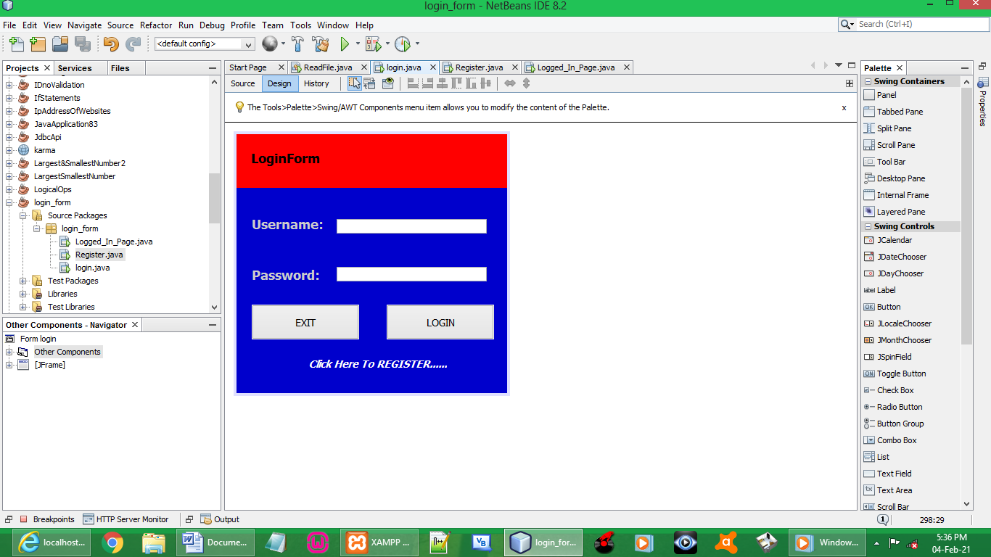

CODES:

import java.sql.Connection;
import java.sql.DriverManager;
import java.sql.PreparedStatement;
import java.sql.ResultSet;
import java.sql.SQLException;
import java.util.logging.Level;
import java.util.logging.Logger;
import javax.swing.JOptionPane;

BUTTON EXIT:

System.exit(0);

LABEL EXIT:

Register reg = new Register();
reg.setVisible(true);

BUTTON LOGIN:

String username = txtUsername1.getText();
String password = String.valueOf(txtPassword1.getPassword());

PreparedStatement pstmt;
ResultSet rs;
Connection cnx = null;

String query = "SELECT * FROM wifi WHERE Username = ? AND Password = ?";

try {

cnx = DriverManager.getConnection("jdbc:mysql://localhost/bosman","root","");

pstmt = cnx.prepareStatement(query);

pstmt.setString(1, username);
pstmt.setString(2, password);

rs = pstmt.executeQuery();

if (rs.next()) {

Logged_In_Page lip = new Logged_In_Page();
lip.setVisible(true);
lip.jLabel1.setText("WELCOME " + txtUsername1.getText());

this.dispose();
}
else {

JOptionPane.showMessageDialog(null, "Incorrect Username or Password");

}

} catch (SQLException ex) {
Logger.getLogger(login.class.getName()).log(Level.SEVERE, null, ex);
}

CREATE THE LOGGED IN JFRAME

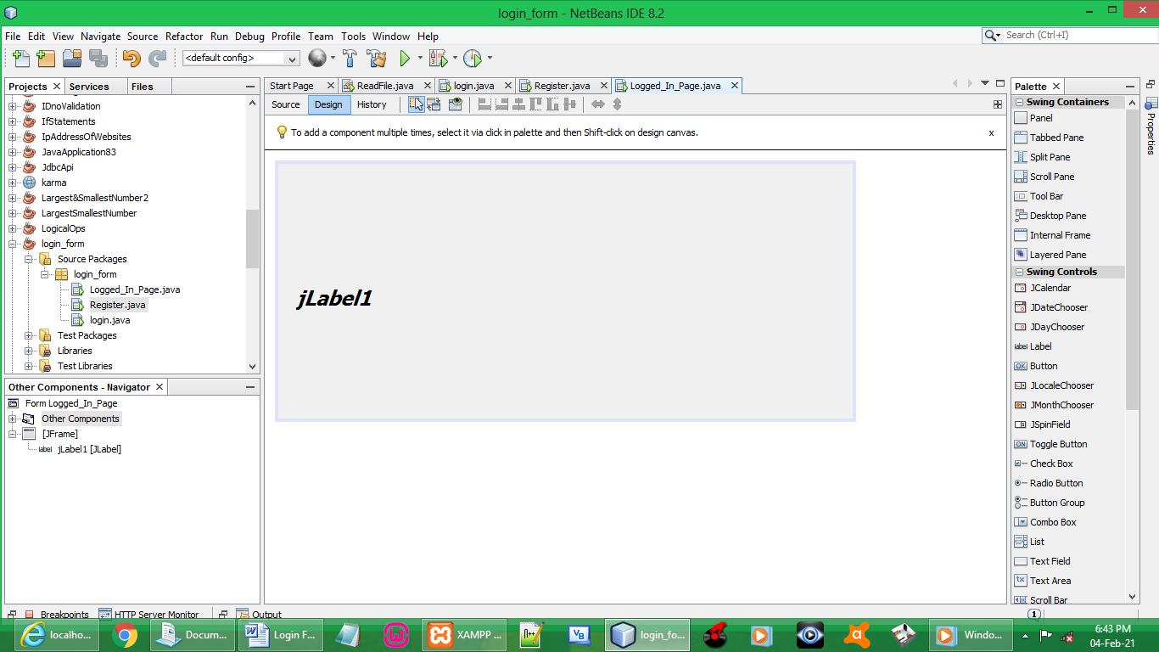

Drag label

Increase label font

// if this line in Login jframe:
// lip.jLabel1.setText("WELCOME " + txtUsername1.getText());
// on variable name is underlined & suggested to make label private
// DO THE FOLLOWING

Go to Customize Code:
Select Protected on Access drop-down-menu
Then Click OK

OUTPUT:

RUN LOGIN FORM

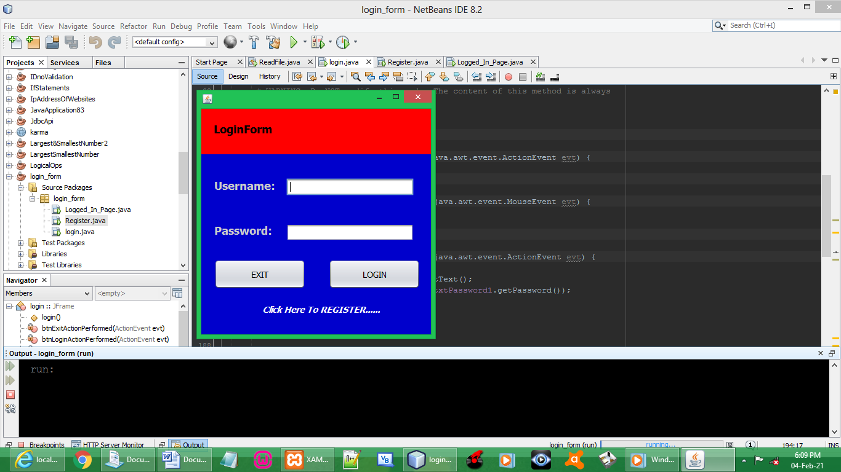

CLICK LABEL TO REGISTER

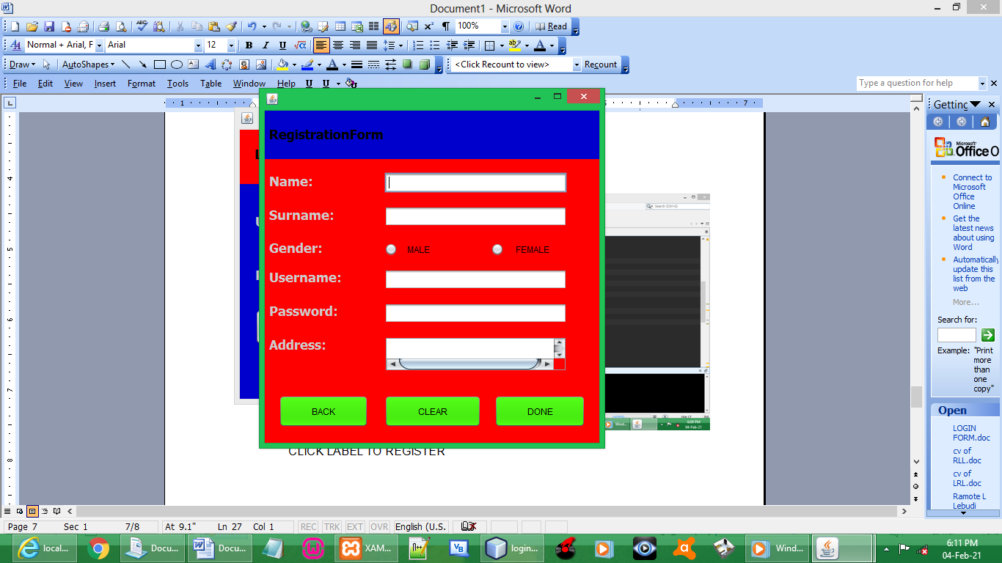

TESTING EMPTY SPACES

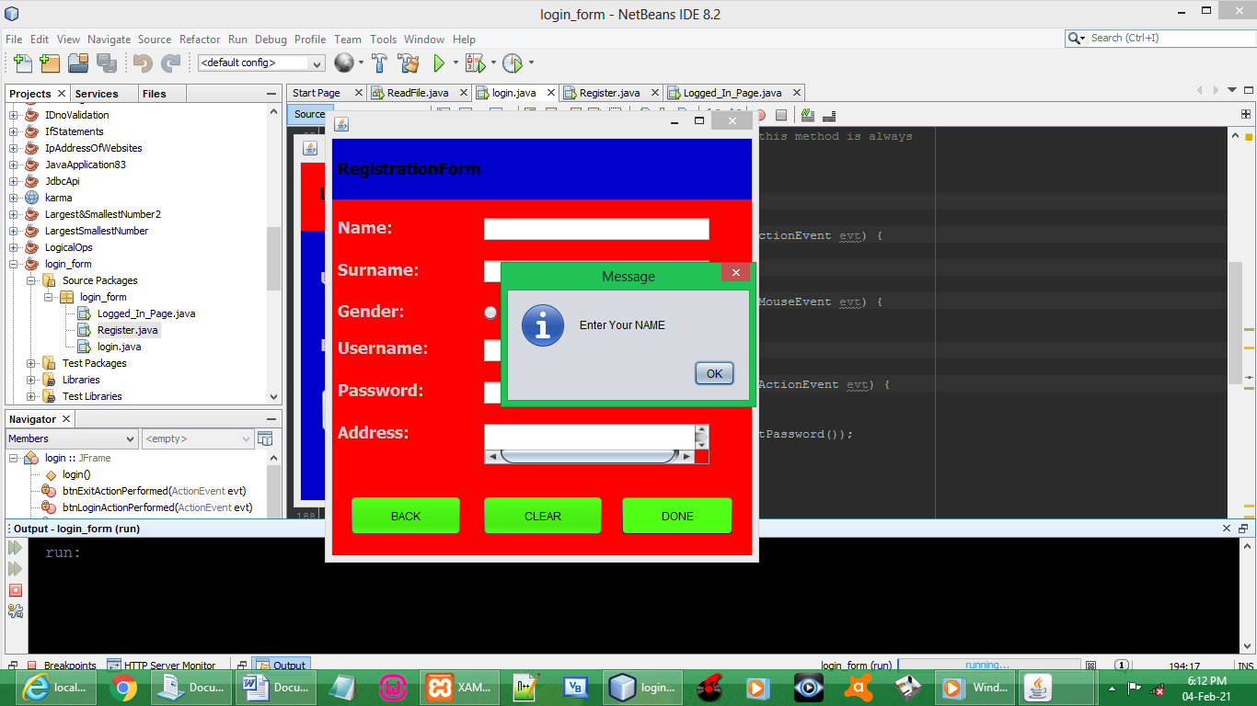

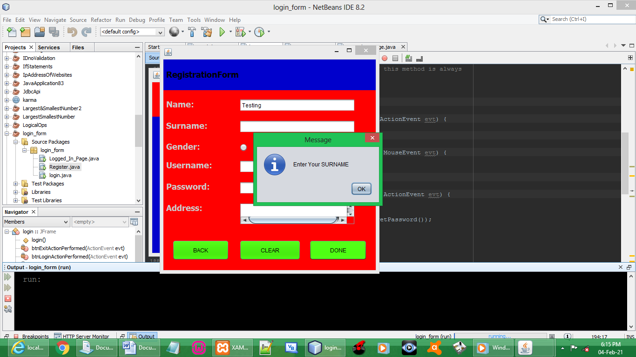

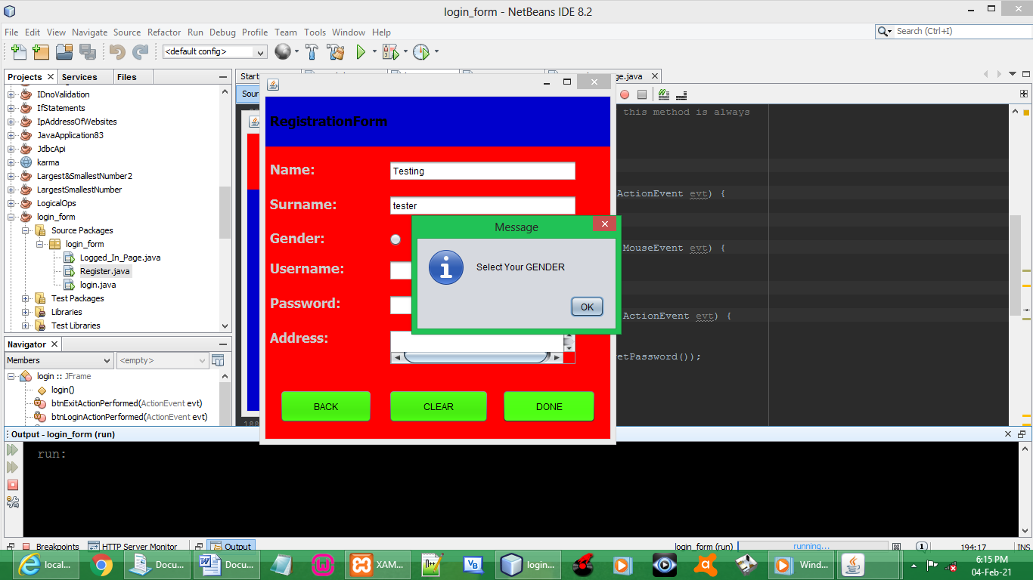

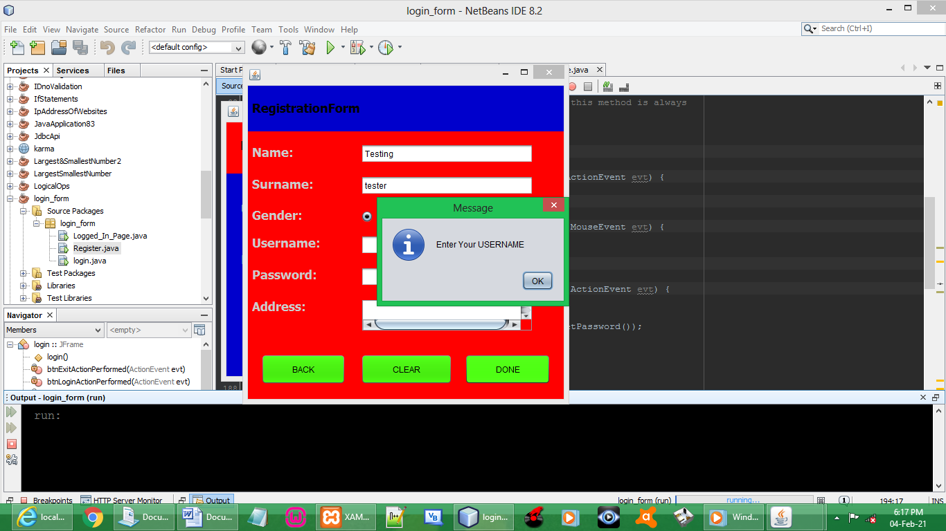

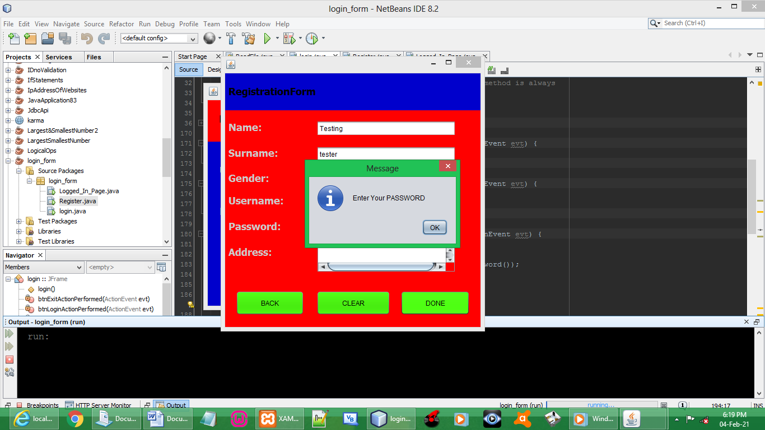

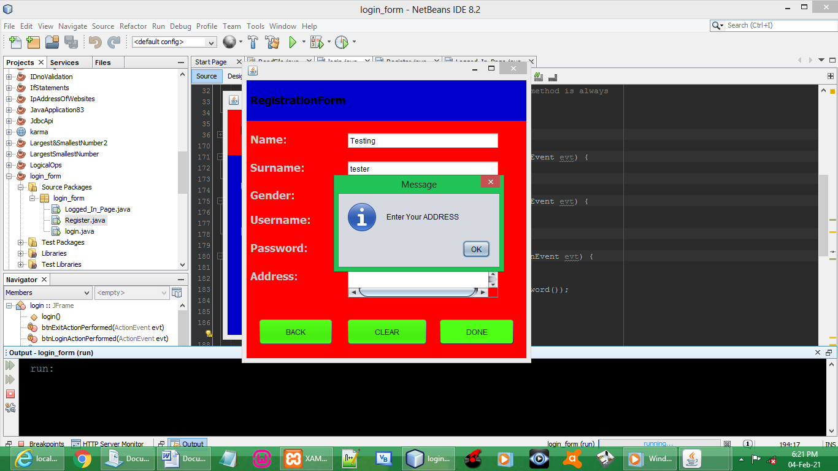

TESTING DONE BUTTON

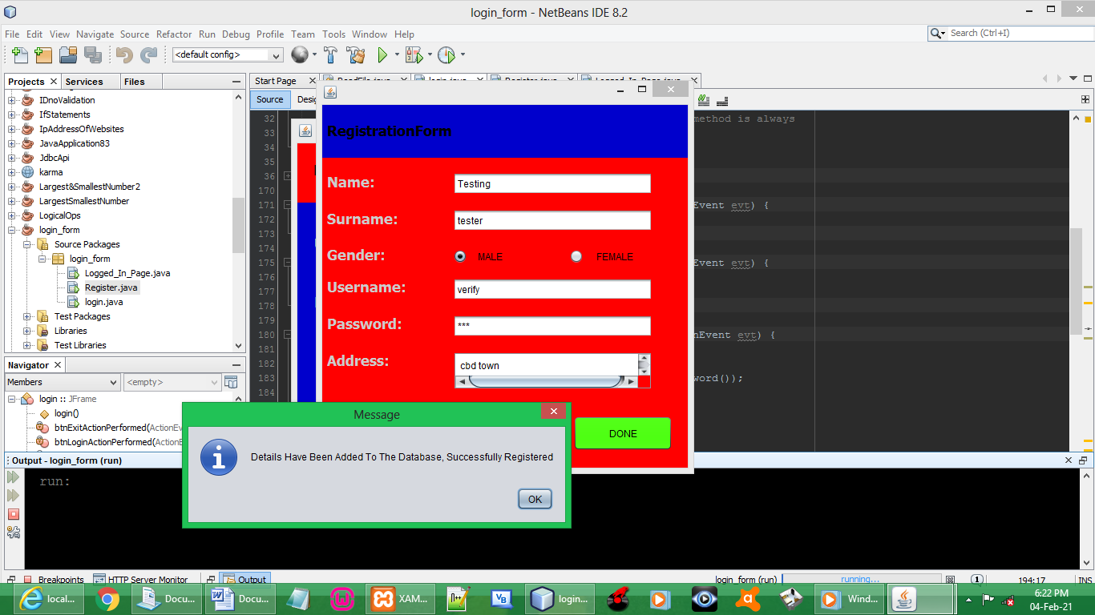

CHECK DETAILS IF ADDED

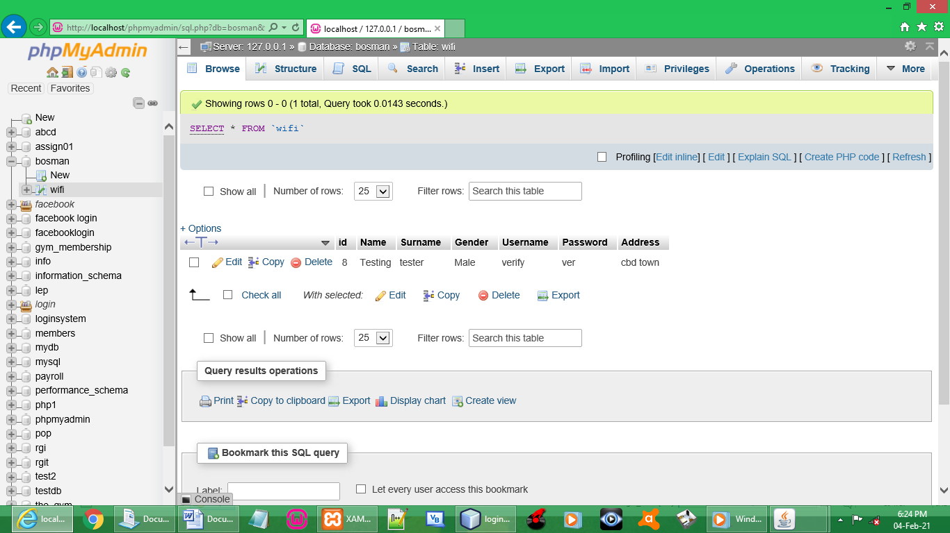

TESTING AN EXISTING USERNAME CAN BE ADDED

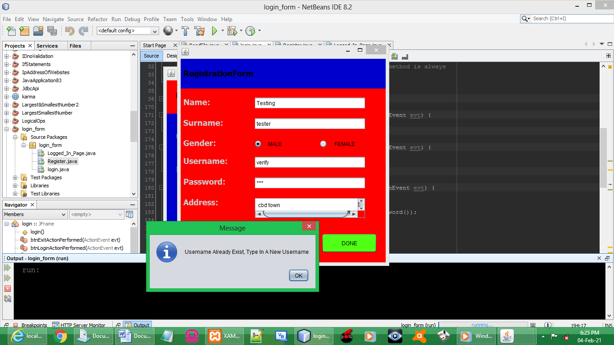

TESTING CLEAR BUTTON

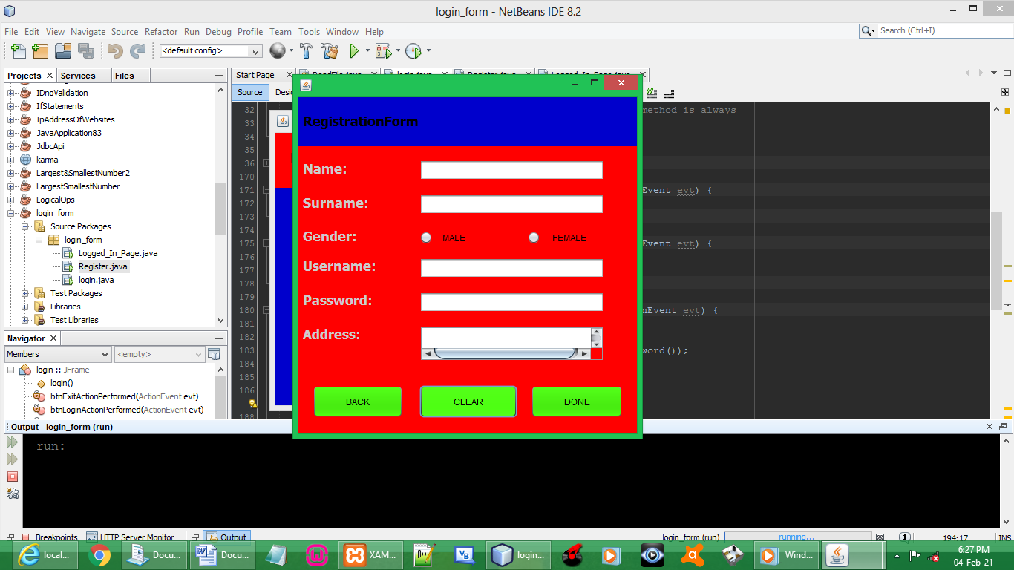

TESTING BACK BUTTON

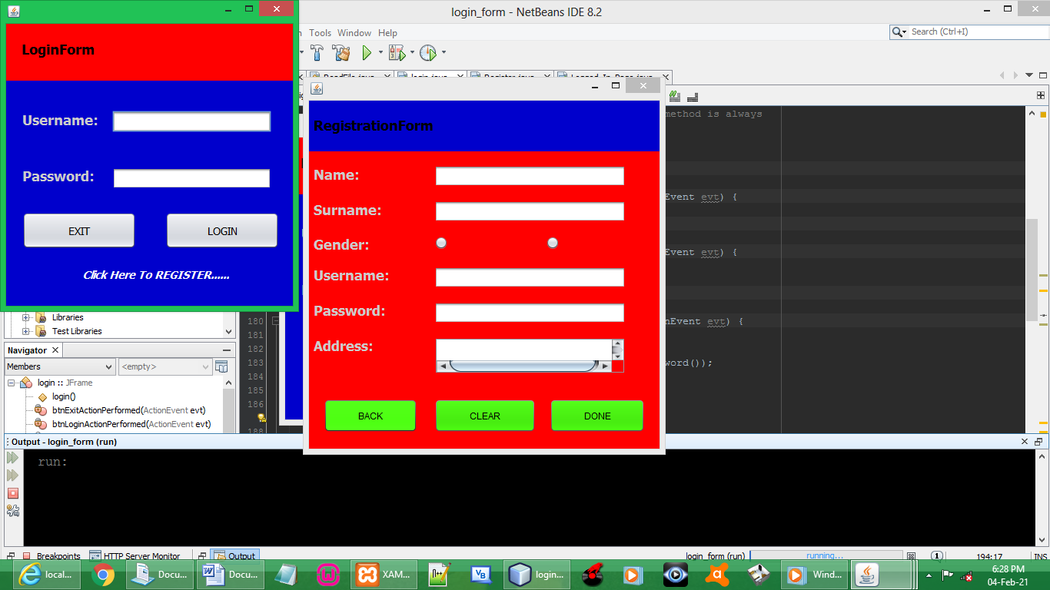

TESTING INCORRECT LOGIN DETAILS

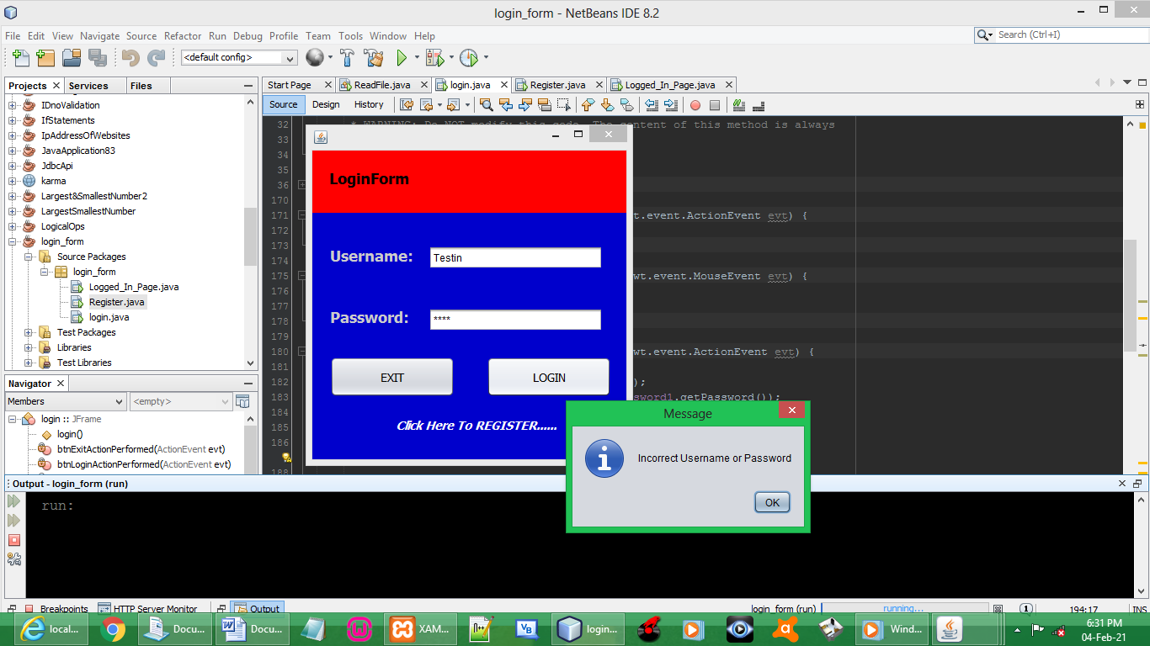

TESTING CORRECT LOGIN DETAILS

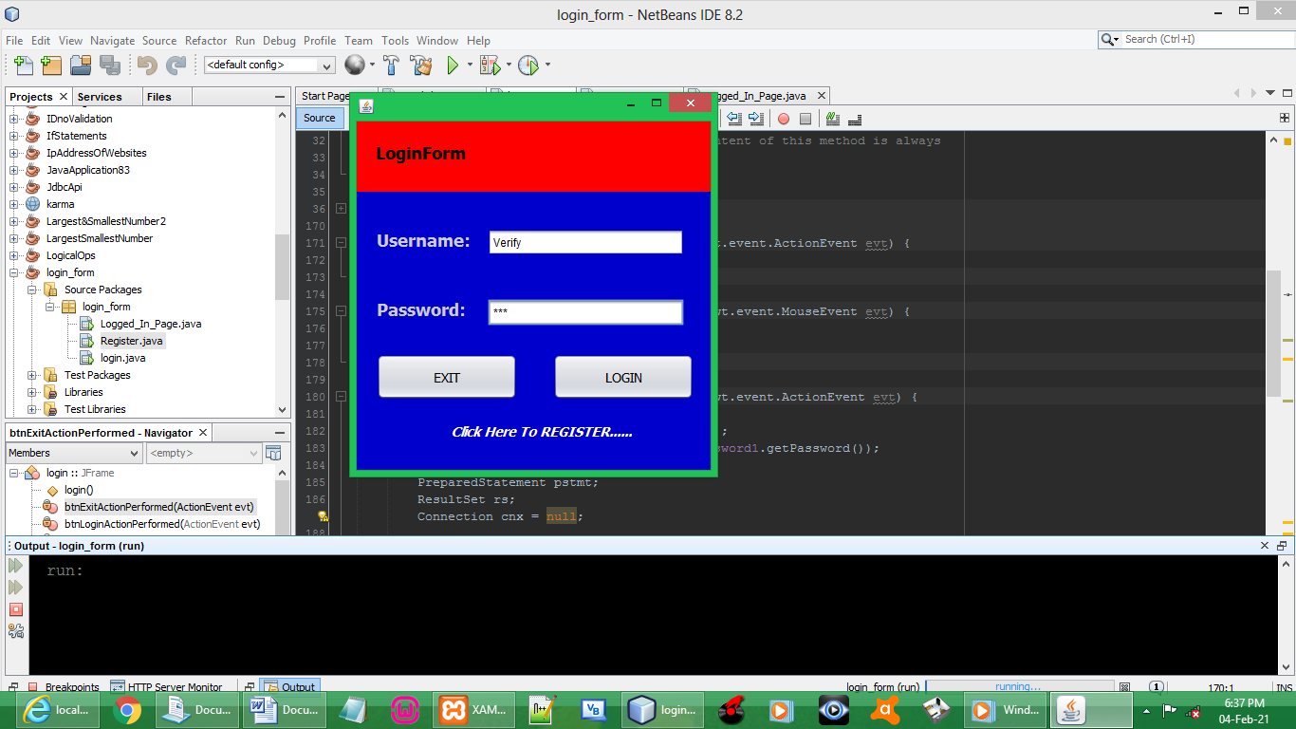

SUCCESS LOGIN

